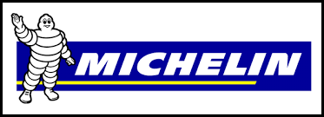
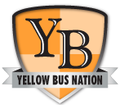

How to purchase on the Yellow Bus Nation Michelin National account:

Go to www.yellowbusnation.com and login to the Members only area for the documents listed below after receiving your account information contact your local Michelin dealer for purchasing.
- Fill out the enrollment application and attach your Sales Tax Exemption certification (if applicable) and return both to Caleb Pack of Michelin (Caleb’s contact information is below).
- Caleb will enter your information into the Michelin system. It typically takes one week to be approved and you will be emailed your Bill To and Ship To numbers.
- View the Yellow Bus Nation – Tire Guide and YBN – Michelin Member Pricing
  - Choose the tires, retreads and service you need
- Visit www.Michelinb2b.com and create a Michelin online account if it is your first time.
  - Right hand column choose the first bullet
  - Fill out the account information, you will need your Ship To and Bill To numbers
- Contact your local Michelin dealer and order the tires, retreads, and services desired.
- The Michelin dealer will bill you at the time of delivery if a credit card is used or an invoice will be generated if you have established a house account (contact Caleb to set-up), you will need the following:
  - Yellow Bus Nation Michelin National Account Number: HO1456294
  - Your Bill-To Number (“BT” followed by 7 numbers)
  - Your Ship-To Number (“ST” followed by 7 numbers)
  - A Visa, MasterCard or American Express credit card number, name, and expiration date
If you have any questions regarding Yellow Bus Nation please contact: Ashley York at 504-323-5838 or email ashley.york@yellowbusnation.com. If you have any questions about Michelin please contact: Caleb Pack, Territory Manager at Michelin: phone 803-457-5673 or email at caleb.pack@michelin.com

